- \Operation\Robot\Home position
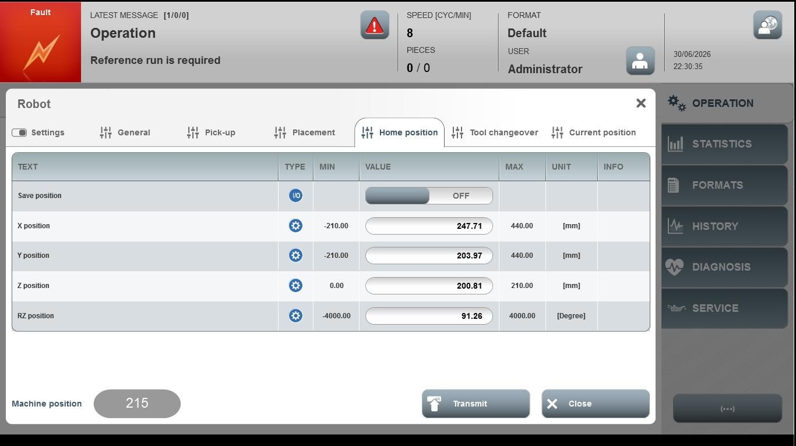
Acceptance criterion | Limits | Pass / Fail: Dev-No. | Date | Initials
Screen matches screenshot | N / A
X-position | -210.00 … 440.00
Y-position | -210.00 … 440.00
Z-position | 0.00 … 210.00
RZ-position | -4000.00 … 4000.00

